**CN Quiz 5**

Name: Erwin Wu

Student ID: 17M38147

**Show the final status of current estimates and their certainty after Dijkstra’s algorithm is performed from vertex 1.**

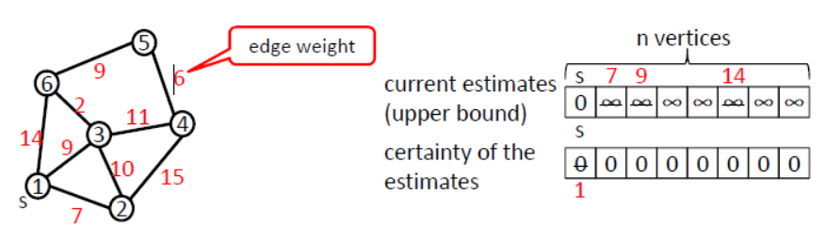

First step (Vertex 1)

|  |  |  |  |  |  |  |
| --- | --- | --- | --- | --- | --- | --- |
| Estimates | 0 | 7 | 9 | ∞ | ∞ | 14 |
| Certainty | 1 | 0 | 0 | 0 | 0 | 0 |

Step 2 (Vertex 2)

|  |  |  |  |  |  |  |
| --- | --- | --- | --- | --- | --- | --- |
| Estimates | 0 | 7 | 9 (17) | 22 | ∞ | 14 |
| Certainty | 1 | 0 | 0 | 0 | 0 | 0 |

Step 3 (Vertex 3)

|  |  |  |  |  |  |  |
| --- | --- | --- | --- | --- | --- | --- |
| Estimates | 0 | 7 | 9 | 20 | ∞ | 11 |
| Certainty | 1 | 0 | 0 | 0 | 0 | 0 |

Step 4 (Vertex 4)

|  |  |  |  |  |  |  |
| --- | --- | --- | --- | --- | --- | --- |
| Estimates | 0 | 7 (35) | 9 | 20 | 25 | 11 |
| Certainty | 1 | 1 | 0 | 0 | 0 | 0 |

Step 5 (Vertex 5)

|  |  |  |  |  |  |  |
| --- | --- | --- | --- | --- | --- | --- |
| Estimates | 0 | 7 | 9 | 20 | 25 | 11 (34) |
| Certainty | 1 | 1 | 0 | 0 | 0 | 1 |

Final Step (Vertex 6 and loop from 1 to check)

|  |  |  |  |  |  |  |
| --- | --- | --- | --- | --- | --- | --- |
| Estimates | 0 | 7 | 9 | 20 | 20 | 11 |
| Certainty | 1 | 1 | 1 | 1 | 1 | 1 |